PROTOCOL (SCOTLAND)

Identification and characterization of the clinical toxicology of novel psychoactive substances (NPS) by laboratory analysis of biological samples from recreational drug users.

Short title – Identification Of Novel psychoActive substances (IONA)

Chief Investigator
Prof SHL Thomas
Professor of Clinical Pharmacology and Therapeutics, Newcastle University
Consultant Physician, Newcastle Hospitals NHS Foundation Trust (Royal Victoria Infirmary)
Director, National Poisons Information Service (Newcastle) Unit.

Address Medical Toxicology Centre, Wolfson Building, Newcastle University,
Newcastle NE2 4HH

Email simon.thomas@ncl.ac.uk
Tel 0191 222 8095

Sponsor Organisation Newcastle Hospitals NHS Foundation Trust (R&D Ref 7312)
Funding Organisations
2015-20 National Institute for Health Research (Ref HPRU-2012-10076)
2020-21 Public Health England

IRAS References 172425 (Scotland), 168706 (England and Wales),
REC References Scotland: Scotland A REC – 15/SS/0047
England and Wales: North East - Newcastle& North Tyneside 2 - 15/NE/0023
Project website https://www.ncl.ac.uk/hpru/research/neurological-disorders/nps-acute-toxicity-documents/

Start date 9th November 2015
End date 31st July 2024
Duration 105 months

TABLE OF CONTENTS

TABLE OF CONTENTS 2
ABBREVIATIONS 3
SUMMARY 5
INTRODUCTION 7
Novel Psychoactive Substances 7
Drug control in the UK 9
Research in progress 10
Research gaps 11
Circulating microRNA biomarkers of drug-induced muscle injury 12

AIMS AND OBJECTIVES 13
METHODS 14
Type of study 14
Participants 14
Research methods 14
Confidentiality and data protection 20
Statistical aspects 21
Research approvals 22
Analytical methods 22
Circulating miRNA biomarkers of drug-induced muscle injury 23
Mathematical and modelling methods 24
Dissemination of research results 24

REFERENCES 25

APPENDIX 1: Classification of NPS and related traditional recreational drugs 30
APPENDIX 2: Schedule of events and sample sizes 31
APPENDIX 3: Data collection sheet 32
APPENDIX 4: Substances detected by current extended drug screen. 36

ABBREVIATIONS

25I-NBOMe | 2-(4-iodo-2,5-dimethoxyphenyl)-N-[(2-methoxyphenyl)methyl] ethanamine
2-AI, | 2-aminoindan
2C-B | 2,5-dimethoxy-4-bromophenethylamine
2C-E | 2,5-dimethoxy-4-ethylphenethylamine
5-IAI | 5-Iodo-2-aminoindane
5-IT | 5-(2-Aminopropyl)indole
ACMD | Advisory Council on the Misuse of Drugs
ALT | Alanine transaminase
AM-2201 | (1-(5-fluoropentyl)-3-(1-naphthoyl)indole)
AMT | alphamethyltryptamine
APB | aminopropylbenzofuran
APICA | 1-Amino-5-phosphonoindan-1-carboxylic acid

AST | Aspartate transaminase

BB-22 | 1-(cyclohexylmethyl)-1H-indole-3-carboxylic acid 8-quinolinyl ester
BZP | Benzylpiperazine
CK | Creatine kinase
D2PM | Diphenylprolinol
DEWS | Drugs early warning system
DMAR | Dimethylaminorex
DOB | Dimethoxybromoamphetamine
DOM | Dimethoxy-4-methylamphetamine
ECG | Electrocardiograph
EMCDDA | European Monitoring Centre for Drug Dependency and Addiction
FEWS | Forensic Early Warning System
HDU | High dependency unit
HPRU | Health Protection Research Unit
HU | Designation for SCRAs first synthesized by the Hebrew university
IM | Intramuscular
INR | International Normalised ratio
ITU | Intensive therapy unit
IU | International Units
IV | Intravenous
JWH | Designation for SCRAs first synthesized by John W Huffman
LC-MS/MS | Liquid chromatography-tandem mass spectrometry
LC-QqTOF | Liquid chromatography-hybrid quadrupole time-of-flight mass spectrometry
LOS | Length of hospital stay
MDA | Methylenedioxyamphetamine
MDAI | Methylenedioxy-2-aminoindane
MDMA  miRNA | Methelene dioxy methamphetamine  MicroRNA
MRC | Medical research Council
MRM | Multiple reaction monitoring
MS | Mass spectrometry
MS/MS | Tandem mass spectrometry
MT-45 | 1-cyclohexyl-4-(1,2-diphenylethyl)piperazine
NHS | National Health Service
NPIS | National Poisons Information Service
NPS | Novel psychoactive substance
npSAD | National Programme on Substance Abuse Deaths
ONS | Office for National Statistics
PALS | Patient Advice and Liaison Service
PMA | Paramethoxyamphetamine
PLR | Professional legal representative
PMMA | Paramethoxymethamphetamine
PPI | Patient and public involvement
PSS | Poisoning Severity Score
PT | Prothrombin time
RCS4 | 1-pentyl-3-(4-methoxybenzoyl)indole
SC | Subcutaneous
SCRA | Synthetic cannabinoid receptor agonists
STS | N-(adamantan-1-yl)-1-(5-fluoropentyl)-1H-indole-3-carboxamide
SWATH | Sequential Windowed Acquisition of all THeoretical mass spectra
TCDO | Temporary class drug order
UKPID | UK Poisons Information Database
UR | (1-pentylindol-3-yl)-(2,2,3,3-tetramethylcyclopropyl)methanone
WEDINOS | Welsh Emerging Drugs and Identification of Novel Substances
XLR | 5"-fluoro-UR-144
α-PVP | α-Pyrrolidinopentiophenone

SUMMARY

The epidemiology of recreational drug use has changed in recent years as a result of the increasing use of new recreational drugs, sometimes termed Novel Psychoactive Substances (NPS) or ‘legal highs.’ These are an increasing healthcare challenge, with 73 new substances reported to the Drugs Early Warning system in Europe in 2012 and 81 in 2013. These substances are associated with significant acute toxicity with 56 deaths reported in England and Wales during 2012 and numerous non-fatal episodes of toxicity presenting to hospitals. The effects of chronic exposure are usually unknown, but traditional drugs of misuse that are chemically related to some NPS have been associated with serotonergic neurotoxicity and there is emerging but inconsistent evidence of chronic neurotoxicity in animal studies after exposure to some NPS.

Prior to this study, there was no systematic national UK data collection system linking analytically confirmed use of NPS with toxicity. As a result, there could be delays before clinicians, public health teams, law enforcement and policy makers were able to define and mitigate the harms associated with specific substances. There were usually no published data available on the pharmacology and toxicity of NPS as they emerge into recreational use, leaving healthcare professionals without evidence to guide patient management in the event of toxicity.

This research aims to address this gap by collating information about substances of misuse, including NPS, implicated in episodes of acute toxicity in the UK. This will involve collection and analysis of samples from consenting patients presenting to participating emergency departments with severe toxicity associated with suspected recreational drug use, with patient consent.
Samples will be subjected to detailed toxicological analysis using state of the art discovery methodology, informed by the latest information on NPS being encountered by clinicians in the UK, as advised by NPIS, and in Europe, as provided by the European Monitoring Centre for Drug Dependency and Addiction (EMCDDA).

The research will identify trends in analytically confirmed substances of misuse, including NPS, causing acute toxicity and presentations to UK hospitals and will link specific substances with reported features of toxicity.

INTRODUCTION

Novel Psychoactive Substances
The epidemiology of recreational drug use has changed substantially in recent years with rapidly increasing use of Novel Psychoactive Substances (NPS) in the UK and internationally. These compounds, sometimes erroneously referred to as 'legal highs' or ‘research chemicals’, are usually chemically similar to traditional drugs of misuse (e.g. amphetamine, MDMA [‘ecstasy’], tryptamines, ketamine, cannabinoids, cocaine or opioids) but with alterations made to the chemical structure so that the new compound is no longer captured by national control of drugs legislation, such as the Misuse of Drugs Act in the UK.¹ Recent examples of NPS include cathinones (e.g. mephedrone), benzofurans (e.g. 5/6 APB), NBOMe compounds,⁶⁻⁸ tryptamines (e.g. alpha methyltryptamine⁹⁻¹¹), piperazines (e.g. benzylpiperazine), benzodiazepines (e.g. etizolam¹⁴), arylcyclohexamines (e.g. methoxetamine¹⁵⁻¹⁷), synthetic cannabinoid receptor agonists (SCRAs),¹⁸⁻²² and synthetic opioids (e.g. MT-45). A more detailed classification of NPS and related drugs of misuse is provided in Appendix 1.

Alterations to the chemical structure of a drug of misuse to produce a NPS can result in a different toxicity profile. As NPS are not subject to any testing prior to distribution and use, some may produce severe and unexpected toxic effects. This may occur as a result of unexpectedly high potency (a low dose is required to produce desired and toxic effects), increased intrinsic toxicity (e.g. toxic effects occur at doses close to those needed to produce the desired effects) or a change in pattern of toxic effects. The All Party Parliamentary Group for Drug Policy Reform have stated that
‘the greatest risk to young people from new psychoactive substances derives from the absence of reliable information about the contents and strength of each new substance and its effects both short and long term’ ²⁵

NPS present particular challenges to health services because of the rapid emergence of large numbers of different compounds. For example, there were 73 NPS reported in the European Union in 2012, 81 in 2013 and 37 in the first 5 months of 2014, bringing the number monitored to approximately 400.²⁶ A further challenge is the lack of available information on their pharmacology or toxicology as there is usually little or no research into these aspects before they are introduced onto the market.

Legal or otherwise, NPS may cause significant acute harms; the Office for National Statistics (ONS) reported 56 deaths in England and Wales in 2012 where an NPS was mentioned on the death certificate following a drug-related death, almost double the figure for 2011.²⁷ ONS also reported increases in deaths related to specific newer recreational drugs including cathinones (from 6 to 18) and paramethoxyamphetamine (PMA) or paramethoxymethamphetamine (PMMA, from 1 to 20) between 2011 and 2012.²⁷ There is a lack of available information on indicators of morbidity, such as numbers of hospital attendances or admissions after use of NPS, although enquiries from health professionals to the UK National Poisons Information Service are common and increasing.²⁸ For most NPS there is almost no available information on the longer term effects of repeated exposure in humans, although severe chronic bladder toxicity may occur after repeated exposure to methoxetamine, as also occurs after exposure to ketamine,a related traditional drug of abuse.²⁹ Traditional drugs of misuse related to some NPS have been associated with serotonergic neurotoxicity³⁰ and there is emerging but inconsistent evidence from animal studies of chronic neurotoxicity after exposure to some NPS.

Recent data from product seizures or forensic analysis of samples taken from patients has suggested that some deaths from opioid toxicity have involved novel opioids rather than conventional opioids such as heroin or methadone. Examples of novel opioids include fentanyl derivatives ( e.g. acryloyl-,acetyl-, car-, thio-, 2-fluoro-, oc-, valeryl-, furanyl-, despropionyl-2-fluoro-, tetrahydrofuranyl, 4Cl-iBF, 4F-iBF, etc), AH-7921, U47,700, U49,900 and MT-45.

This lack of evidence about acute harms and long term effects from use of NPS has been identified as an important evidence gap in a recent Home Office report.⁴¹A further difficulty is that the chemical composition of products sold may not be known or may not be as advertised to the user⁴² and may vary⁴³ or involve a mixture of compounds,²⁶ some of which can be illegal.

There is evidence from the UK that legal control of NPS can reduce the frequency of presentations to health services with clinical toxicity associated with that substance. This may be a direct effect of restricting supply, but could also occur because the publicity associated with legal control may better inform clinicians and users about the harms associated with use. For example, for the synthetic cathinone mephedrone (‘M-Cat’), enquiry numbers to the UK NPIS peaked in April 2010 and subsequently declined sharply after legal control; ² a similar pattern was observed in one emergency department.⁴⁶ These changes are accompanied by evidence of a reduced prevalence of mephedrone use.⁴¹ Reductions in telephone enquiries to the NPIS about cases of toxicity also fell after legal control of methoxetamine.¹⁵ However, legal control of one drug may channel users towards other recreational drugs, including newer NPS, the harms of which may be at least as great as the drug being controlled. As a result, the overall impact of control measures on recreational drug related morbidity and mortality remains uncertain.

Drug control in the UK
In the UK, legal control of drugs of misuse is determined by the Home Office after advice by the Advisory Council on the Misuse of Drugs (ACMD). For control to be recommended under the 1971 Misuse of Drugs Act there must be evidence of harms associated with the drug, such as adverse societal impact or evidence of acute or chronic toxicity. From November 2011, the Misuse of Drugs Act 1971 has been amended to enable the temporary control of an NPS by invoking a temporary class drug order (TCDO). This requires that the substance is not already controlled and is subject to advice from the ACMD that the drug is likely to be misused and misuse is capable of having harmful effects. TCDOs need Parliamentary endorsement within 40 sitting days and last for up to 12 months. This is expected to provide adequate time for the ACMD to provide full, independent and expert advice about the need for permanent control. Mechanisms are therefore needed for rapid collection of information on the potential harms of emerging substances to inform ACMD decisions on TCDOs and permanent control.

The NPIS have published data on the emergence of clinical harm associated with NPS and these data correlate with data from other sources such as the EMCDDA, mortality data published by ONS, published case series and case reports.⁴⁷ NPIS data, however, are currently limited by the lack of analytical confirmation of the exact substance(s) involved, relying on information provided by the patient or witnesses. This is suboptimal because preparations sold as one drug may on analysis be found to contain others, delaying the detection and characterization of emerging recreational substances.

Research in progress
Various non-systematic and sometimes unfunded research projects are already in place to provide analytical confirmation of NPS in use in the UK. Samples may be taken on an ad hoc basis from patients presenting with toxicity when clinicians are aware of laboratories that are able to provide the appropriate analysis. This has provided invaluable information linking features of toxicity with chemical composition, but the data collection is not systematic so sample sizes are limited and often geographically confined. Nationally, most patients present with toxicity without analysis of their samples taking place and this may delay identification of new drug issues. Nevertheless, examples of NPS identified and linked to clinical effects, often by research teams involved in the current project, include mephedrone ⁵⁰ desoxypipradrol ⁵¹, D2PM⁵², methoxetamine and 25I NBOMe ⁷.

Biological samples from patients may also be analysed as part of the forensic analysis of drug-related deaths and this provides essential information which is collated by the National Programme on Substance Abuse Deaths (npSAD). This has reported an increasing number of cases where a NPS has been listed as the cause of death from 10 in 2009 to 68 in 2012.⁵³ This project, however, is no longer funded and is not collecting information within a meaningful time frame.

The Home Office currently funds a Forensic Early Warning System (FEWS).⁵⁴ This is restricted to analysis of powders, such as those seized by customs or police forces. Since inception FEWS has analysed more than 4,500 samples and from these identified 31 novel substances.⁵⁵ This provides useful evidence of drugs in circulation but cannot be used to link these substances with particular clinical features of toxicity.

The Welsh Emerging Drugs and Identification of Novel Substances (WEDINOS) project was launched in 2013 for the collection and testing of new psychoactive substance (NPS), with dissemination of pragmatic evidence-based harm reduction information via a website.⁵⁶ Users are able to send samples of drug they have purchased and also details of clinical features they have experienced from use. Although focused on Wales, the project accepts and analyses drug samples from throughout the UK. From October 2013 to March 2014 the project received and analyzed 703 samples and in the most recent quarter year notified 12 new substances to the EMCDDA.⁵⁷ This project, however, does not routinely collect blood or urine samples from patients experiencing toxicity, although there may be some capacity for this on an ad hoc basis. Drug samples provided by users give an indication of the content of substances in circulation but do not necessarily reflect the substances that are actually being consumed.

Research gaps
There is therefore a currently unmet need for a system that provides the opportunity for detailed analysis of blood, urine or other biological samples from users of recreational drugs who experience toxicity irrespective of where they present in the UK. This needs to be simple to access, well publicised to the relevant health professionals and drug user groups, have the appropriate ethical and regulatory approvals in place and be able to link biological exposure with evidence of clinical toxic effects. This would be consistent with the Independent Scientific Committee on Drugs recommendation to

‘Monitor any hospital Accident & Emergency presentations, and clinical assessments, and confirm by urine analysis’.

A project of this type, termed STRIDA, initiated in Sweden in January 2010, demonstrates the value of this approach. STRIDA received samples from 103 patients in the first year of operation, and the most common NPS groups identified were synthetic cannabinoids (22), substituted cathinones (11) and substituted tryptamines (9) ⁵⁸. The STRIDA project has been able to identify emerging NPS and relate exposure to features of toxicity, e.g. 5-IT ⁵⁹ and MT-45.²⁴ Other similar projects are operating around the world, but do not provide UK-specific information linking analytically confirmed exposure with toxic effects.

Circulating microRNA biomarkers of drug-induced muscle injury

Drug-induced skeletal muscle toxicity is a serious liability illustrated by cerivastatin (Baycol), the 3-hydroxy-3-methylglutaryl-coenzyme A (HMG-CoA) reductase inhibitor that was withdrawn from the market in 2001 after it was associated with 100 rhabdomyolysis-related deaths. Furthermore, the incidence of skeletal muscle injury is becoming increasingly more prevalent in preclinical evaluation of new therapeutic targets. At the same time, commonly used serological biomarkers, including creatine kinase (CK), aldolase, and aspartate aminotransferase (AST) lack sensitivity and specificity, particularly in rats, and this limitation precludes their utility as accurate biomarkers of skeletal muscle toxicity. Consequently, preclinical detection of skeletal muscle toxicity is typically confirmed by histopathologic evaluation, with serological biomarkers serving only as adjuncts to the histopathologic findings. Muscle toxicity is common following recreational use of stimulants such as novel psychoactive substances.

MicroRNAs (miRNAs) are small (~22 nucleotide-long) non-protein coding RNA species involved in post-transcriptional gene-product regulation. These miRNAs are candidates to act as circulating biomarkers for muscular injury relating to NPS because certain species are muscle specific with proof of concept established for reporting human muscular dystrophies. In blood, miRNAs are stable because they are protected from degradation by extra-cellular vesicles (such as exosomes), RNA binding protein complexes (such as argonaute 2 – Ago2) and high-density lipoproteins. As they are amplifiable and some are tissue restricted, miRNAs represent a reservoir for biomarker discovery. miRNAs are conserved across species making them potential translational safety biomarkers. For example, liver-enriched miR-122 is released by injured hepatocytes and is a circulating biomarker for liver toxicity in zebrafish, rodents and humans.

The objective of this sub-study is to determine whether a panel of miRNAs can report muscle toxicity in humans and to explore the relationship between injury and the drug identified in the circulation, using samples collected during the IONA study.

AIMS AND OBJECTIVES

This project will seek to identify identify substances of misuse, including NPS, that may be involved in toxicity experienced by patients presenting to acute hospitals, especially emergency departments. This will be achieved using analytical evidence of exposure to substances from samples taken either during normal NHS care or, in participating hospitals, for the purposes of this research.

Specific aims of the study are

- Further develop methods of screening, analysis and quantification for new/emerging NPS in biological samples (urine, oral fluid and blood)
- Analyse samples from patients with acute toxicity relating to NPS and other recreational drugs to identify responsible agents
- Link the presence of analytically confirmed recreational drug exposure with the toxic effects experienced
- Measure potential miRNA biomarkers for muscle toxicity and correlate these with clinical data provided to the study such as creatine kinase, temperature etc

METHODS

Type of study

The study will link the reported history of exposure and/or analytical findings with reported clinical features of acute toxicity.

Participants
The target population is recreational drug users presenting to health services (especially emergency departments) with acute severe toxicity associated with suspected recreational drug use.

Research methods

This study will collect samples (blood, urine, oral fluid, the remainder of substances taken) from people presenting to acute NHS hospitals with severe toxicity associated with suspected recreational drug use, with informed consent from those with capacity. This allows the collection of high quality and more complete clinical information according to a pre-specified protocol and also allows clarification of detail directly between the local clinician/researcher and the central research team. Multiple samples may be provided from the same patient, if available and consent has been provided, so that pharmacokinetic and pharmacodynamic information can be collected, including half-life of the parent drug implicated and the formation of metabolites.

While it would be ideal if every UK emergency department was set up as a research site to provide a comprehensive UK-wide coverage, this is not feasible within the financial and administrative resources available. Therefore, this research aspect will involve a restricted number of selected emergency departments where there is a local researcher willing to lead the research in that centre. This will initially be a small number of departments (approximately 10), but the number is expected to grow as the research progresses.

Inclusion criteria | Exclusion criteria
- Patient attending an emergency department with toxicity as a result of suspected drug misuse  - Patient consent (immediate or retrospective) | - Refusal of consent  - No clinical suspicion of drug misuse  - Children and young people <16 y  - Known to be HIV positive*  - Samples collected for investigation of suspected non-accidental injury
*Samples cannot currently be analysed from those who are known to be Human Immunodeficiency Virus (HIV) positive. Note however that there is no requirement for HIV testing before participation. The presence of other blood bourne viruses (e.g. Hepatitis C) is not an exclusion.

Note that participants may be re-entered into IONA if they subsequently present with separate episodes of drug use and provide further consent.

Recruitment and consent arrangements

People meeting the inclusion criteria will be identified by the responsible clinician, who will assess capacity to make a decision about participation in the research. This will occur as soon as possible after admission. It will be assumed that a potential participant has capacity unless there is proof that they do not have capacity for this specific decision, as provided by the capacity assessment made by clinical team.

Potential participants with capacity
If the potential participant has capacity and is willing to discuss the research, they will be seen by a member of the local research team who will verify inclusion and exclusion criteria, explain the study and give them a participant information sheet and consent form. The potential participant will be given the time they need to decide if they are willing to participate and to sign the consent form. It is important to collect initial samples as soon as possible after presentation, but if the potential participant would like more time to consider their decision, it is still possible to include them in the research as they may subsequently consent to previously taken clinical samples held routinely in the NHS lab being used for the research.

As many samples as possible will be obtained by using residuals of those already taken for clinical purposes. However, if these residuals are not available (which will be infrequent), fresh fresh blood samples will be taken for research purposes, but only once written informed consent to participation in the study has been obtained and with the participant’s verbal consent for each additional venepuncture.

Potential participants lacking capacity
Impaired capacity is common in the target participant group because of drug/alcohol intoxication, but it is important that these patients are included in the research as they constitute a more severely affected cohort. Restricting the study to participants with capacity to give consent would substantially reduce the capability of the research to identify rapidly those NPS associated with serious toxicity. Inclusion of patients lacking capacity will entail little or no discomfort, as additional venepuncture for research purposes, in advance of consent, is not proposed.
If capacity is not present it is proposed that residual blood from samples taken for clinical purposes and non-invasively collected oral fluid and/or urine samples are stored locally until the patient regains capacity, at which time delayed consent for provision of these samples for the research, together with the necessary clinical data, can be sought. If consent is refused the samples would be not be used for the research. The justification for collection of samples in advance of consent is that this is time critical, needing to occur as soon as possible after admission, before plasma drug concentrations fall as a result of metabolism and excretion. Note that early blood sampling is part of the routine clinical care of patients presenting with drug toxicity ands storage of residual clinical samples in case of the need for further/repeated analysis is standard practice in NHS biochemistry laboratories.

These consent arrangements allow the study to be discussed directly with the potential participant and for informed consent to be obtained before samples are used for research. This discussion can occur at the time of blood/urine/oral fluid sampling if the potential participant is considered to have capacity, but when necessary, this discussion can be delayed until capacity is restored.

There will be a small number of potential participants who have impairment of capacity that persists, including patients who require prolonged ventilation. In the event of fatal toxicity it is possible that capacity would not be present at any time between presentation and death. Under these circumstances of very severe toxicity, the analysis for responsible NPS is of critical importance.

It is therefore proposed that for research sites in England and Wales, if after at least 6 hours capacity has not been regained, support for inclusion of the potential participant will be sought from a consultee, consistent with Department of Health Guidance and Section 32(3) of the Mental Capacity Act 2005, using arrangements approved by a Research Ethics Committee. This would be a personal consultee if available, i.e. a person who knows the person lacking capacity well, but is not acting in a professional or paid capacity, such as a family member, non-paid carer or friend. If an appropriate personal consultee cannot be identified after reasonable steps have been taken, a nominated consultee (or Professional Legal Representative, PLR) will be approached. Arrangements for nominated consultees will be made locally in research sites, in accordance with DH guidance. Advice on inclusion of the potential participant in the research will be sought using the Participant Information Sheet and recorded using a Consultee Declaration Form.

For research sites in Scotland, arrangements will be consistent with the Adults with Incapacity (Scotland) Act 2008. Consent will be sought from a person with relevant powers (i.e. their guardian, welfare attorney or closest family member if these have not been appointed) if capacity is not regained within 6 h. Consent for inclusion of the potential participant in the research will be sought using the Participant Information Sheet and recorded using the Consent Form (Person with relevant powers).

Note that, irrespective of the advice of consultees (England and Wales) or consent provided by people with relevant powers (Scotland), potential participants without capacity will be informed about the research in as clear and appropriate a way as possible and those that express objections to participation will be not be included.

For patients lacking capacity, where consent has been provided by a person with relevant powers, all samples will be obtained by using residuals of those already taken for clinical purposes. Venepunctures will only be done when this is necessary for the patient’s appropriate clinical management.

In the event of capacity being restored, participants will be asked for consent to continue in the study and this decision will be supported by the participant information sheet. They will be given the option to consent to remain in the study, to decline consent but to allow data and samples already collected to be used for the research or to decline consent and refuse permission. A consent form is available to record this decision. This decision can also be made by telephone, after provision of written information by post.

Occasionally, however, it is not feasible to obtain a decision from the participant because they have left hospital before they can be approached by research staff. When this happens, the participant should be approached by letter and this will be followed up by two telephone calls (if a telephone number has been provided). If they do not respond to the letter and the 2 telephone calls (or the letter alone if no number has been provided), their data will be used for the study in linked-anonymized format. This is explained in the information sheet for consultees (England and Wales) and the Information sheet for the nearest relative./guardian or welfare attorney (Scotland) and the cover letter to person previously included when they did not have capacity.

For patients with fatal toxicity, toxicological screening may be carried out as part of the Coroner’s (Procurator Fiscal in Scotland) investigation and this would take precedence over this research. The clinical and research teams involved would provide samples or analysis results to the Coroner/ Procurator Fiscal as requested. Collation of post mortem toxicology data from coroner’s inquests is not a focus of this project as this has been undertaken by the npSAD study.
Recruitment, capacity and consent arrangements are summarized in the algorithm below.
Recruitment algorithm
Patients with suspected NPS use

No

Exclude

(Destroy any samples already saved)

Yes
Severe toxicity may be present?*

No
Yes
Meets inclusion criteria?

No
Yes
No
Take oral fluid / urine samples and set aside residual blood from venepuncture done for clinical indications

Capacity present?

Reassess capacity after appropriate intervals

Capacity restored

Capacity not restored within 6h or longer

Yes

No

Willing to give consent

Sign consent forms and recruit

Take / secure samples and clinical data

Yes
Research team actions
Clinical team actions

Seek advice from

England and Wales
- personal consultee
If unavailable/unwilling
- nominated consultee
Scotland
- Person with relevant powers
(see text)
Supports/consents to participant inclusion?

Yes
Sign consultee or consent forms and recruit

No
For those included when they did not have capacity
* Any toxicity in Scotland
Schedule of events and participant numbers
The schedule of events, including annual participation numbers, is provided in Appendix 2

Data provided

As well as biological samples (described above), research sites will supply demographic and clinical information using a structured data collection form (Appendix 3).

Analysis of biological samples
Biological samples from Scotland were analysed in the Scottish Police Authority Forensic Laboratories in Edinburgh from 2015 to 2019. Following substantial amendment 3 (12th January 2017) ethical approval has been in place for samples to be sent to other forensic laboratories for quality control purposes (Medical Toxicology Centre, Newcastle University and LGC, Cambridgeshire, England). Following the adoption of Substantial Amendment 4 (6th January 2020) primary sample analysis has taken place at LGC.

Confidentiality and data protection

All identifiable data used in the research will be held in the Newcastle Hospitals NHS Foundation Trust, with electronic data stored on password protected computers. Processing of data will be subject to standard NHS data protection policies with approval from the Trust Caldicott Guardian. As for all NHS staff, those with access to the data will be subject to NHS policies and procedures for information governance. Fully anonymised research results will be shared with research partners as needed for analysis, interpretation and writing up of reports and papers.

It is acknowledged that there is a theoretical risk of inadvertent identification of patients, for example by triangulating the clinical information collected with media reports that might identify an individual. The study team will take all reasonable steps to minimize this risk.

Clinical records will be retained by the local researcher. Information passed on to the research team in Newcastle will include a study number, the age, sex and postcode (first 4 digits) of the patient, the nature and timing of the exposure, the source of the recreational drugs (internet, shop, dealer, friend, relative or other), the timing of sample collection and the recorded clinical features (using a structured data collection form as shown in Appendix 3). The great majority of samples and data will be provided with consent in place at the time of transfer to the research team, but there will be a small number of samples collected without consent from adults with incapacity. Arrangements are in place to allow this by means of appropriate declarations from personal or nominated consultees (England and Wales) or consent from persons with relevant powers (Scotland).

Statistical aspects

Information on expected numbers of patients and samples are provided in the Table below. There is uncertainty about the amount of data that may be available for studies 2-4 and these numbers will be updated as necessary by a protocol amendment as the study progresses.

Descriptive statistics will be used for studies 1 and 2 and will characterize the epidemiology of poisons service enquiries about NPS and of positive toxicology screening samples handled in NHS Toxicology laboratories.

For studies 3 and 4, formal statistical analysis is unlikely to be required. Useful data linking particular features of toxicity with analytical conformation of exposure is valuable even if this is achieved in a single patient.

No hypothesis testing, e.g. comparing toxicity between agents, is envisaged for data collected in any of the studies and as such formal power calculations are not needed.

Research approvals
Ethical approval for the study has been obtained from responsible Research Ethics Committees. Research Management and Governance approvals will be sought as appropriate from participating NHS organizations (NHS Trust Emergency Departments participating in study 4 and NHS Trust Toxicology laboratories participating in studies 2-4).

As part of this process, appropriate Material Transfer Agreements/Contracts will be arranged to allow transfer of biological samples between research sites. These samples will be kept in accordance with local policies and destroyed once analysis has been completed or within 1 year of the end of the 5 year research project (whichever is the earliest). A license from the Human Tissue Authority is not needed for storage of samples collected with ethical approval.

Analytical methods

Blood, plasma, urine and oral fluid samples will be analysed for a range of psychoactive substances using modern mass spectrometric based techniques. A major challenge for the analysis of novel psychoactive substances is that new substances with unknown metabolites are constantly emerging. A combination of targeted screening – Multiple Reaction Monitoring, precursor and neutral loss ions scans – and high resolution data dependent and data independent methodologies will be utilized, using triple quadrupole, ion trap and time of flight mass spectrometers, to provide a comprehensive profile of the emerging psychoactive substances and their metabolites. Psychoactive substances and metabolites will be identified using an integrated workflow incorporating qualitative exploration, rapid profiling and data interrogation using metabolomic software.

Evaluation of certified analyte reference standards is required for validating methodology. Up to date blood, plasma and urine analytical methods, targeting as many NPSs for which reference standards are currently available, are critical to effectively monitoring NPSs. In addition, these reference materials will be used to create and customise a NPS mass spectral library data base for fast and effective identification and confirmation of unknown compounds.

Nominal-mass multiple reaction monitoring (MRM) triggered product ion spectra detection will be employed for targeted compounds using triple quadrupole or hybrid triple quad-linear ion trap instruments. However, high-resolution and accurate mass tandem MS using time of flight mass spectrometers provide accurate mass information on both the parent molecule and fragment ions, affording greater specificity and potentially simplifying data interpretation. Novel non-targeted analytical techniques using a LC-QqTOF high-resolution tandem mass spectrometer will be employed to identify novel NPSs and their metabolites. Both data dependant and data independent non-targeted methodologies will be developed. The data independent methods will employ SWATH acquisition (Sequential Windowed Acquisition of all THeoretical mass spectra), which sequentially acquires MS/MS of all precursor ions across a specified mass range, by breaking down the mass range into small windows.⁶² In every scan cycle, the instrument rapidly and sequentially acquires MS and MS/MS of all mass windows across the specified mass range. Since the approach is non-targeted, it should not require future modifications for incorporating newly emerging compounds, and MS and MS/MS spectra acquired for unknown compounds can be identified retrospectively via data re-interrogation against the reference spectra in the in-house data base.

Once a new drug has been identified and an appropriate standard is available, this can be added to the targeted screening using LC-MS/MS performed in Toxicology laboratories. A list of substances currently identified by targeted screening at LGC Ltd is provided in Appendix 4.

Circulating miRNA biomarkers of drug-induced muscle injury

To study muscle toxicity an aliquot (100ul) will be taken of the serum/plasma collected (non-heparinised samples only) as part of the IONA study and a panel of muscle-enriched miRNAs (together with control species) will be measured in the university of Edinburgh using PCR techniques established and validated there. The miRNAs will subsequently be correlated with current muscle injury biomarkers (CK) and other patient parameters such as temperature and the drug identified in the sample.

Mathematical and modelling methods

NPIS telephone and TOXBASE enquiries and positive toxicology laboratory samples will be used as indices of NPS use. Temporal trends in both types of enquires will be analysed using time series analyses undertaken at short sample periods, which will be used to alert the HPRU to trends in use. Bayesian disease mapping techniques will be used to analyse spatial and temporal trends in records for NPS. Area-based autoregressive modeling (CAR models) will identify spatial variation in NPS use across the study area, whilst also highlighting potential risk factors (socio-economic status, age distribution etc). State-space time series analysis will be used to investigate the impact of drug control policies and the interplay between telephone and web enquiries.

Dissemination of research results

Research outputs will be discussed with the steering group and reported to the NIHR as funder of the research on an annual basis. Important research findings will be provided to official organizations such as the UK Focal Point, ACMD and EMCDDA, presented at scientific meetings and submitted for publication as appropriate.

Information obtained by the research will be used to inform NPIS guidance for NHS health professionals published on TOXBASE.

Communication of research findings to the general public and particularly potential NPS users is of great importance. This will be achieved via the study website, by articles in the lay media and via local Drug and Alcohol Action Teams. The project is developing robust arrangements for patient and public involvement (PPI) for designing, conducting and reporting the research and this expertise will be used in disseminating research results.

REFERENCES

APPENDIX 1: Classification of NPS and related traditional recreational drugs

Major group | Subgroup | Examples
Synthetic Cannabinoid Receptor Antagonists (SCRAs) | 1st generation | JWH-018, HU-210
 | 2nd generation | AM2201, AM1220, RCS4, UR-144, XLR-11
 | 3rd generation | APICA, STS-135, BB-22, LY2183240, MDMB-CHMICA, 5F-MDMB PINACA
Opioids²⁴ |  | desomorphine, MT-45  Furanylfentanil and other fentanyl analogues
Benzodiazepines¹⁴ |  | Etizolam, diazepam, phenazepam
Indolealkylamines (tryptamines) |  | Dimethyltryptamine, 4-hydroxy,N,N-dimethyltryptamine (Psilocin), alphamethyltryptamine (AMT)
Piperazines |  | e.g. Benzylpiperazine (BZP), mCPP
Arylcyclohexamines |  | Ketamine, methoxetamine, PCP
Phenylethylamine derivatives* | Amphetamines | Amphetamine, methamphatamine, 4-methylamphetamine, PMA, PMMA
 | Cathinones | mephedrone, 3-methylmethcathinone, α-PVP, methylone
 | Benzofurans and difurans | 5-APB, bromodragonfly
 | Aminoindans⁷⁷⁻⁸⁰ | 2-AI, 5-IAI, MDAI
 | D-Series⁸¹, | DOB, DOM
 | 2C-series | 2C-B, 2C-E
 | NBOMe compounds | 25I-NBOMe
 | Methylenedioxy amphetamines | MDMA, MDA
Piperidines and  pyrrolidines |  | D2PM, 3,4-dichloromethylphenidate
Plant extracts |  | Kratom⁸⁸, Salvia,⁸⁹ ibogaine⁹⁰
Others |  | 4,4-DMAR,⁹¹ Ethaqualone, 2-MeO-Diphenidine, methoxphenidine, mephtetramine,⁹² cocaine.
* Overlaps in the structural classification exist such that some chemicals may belong to more than one group. For abbreviations see p6.

APPENDIX 2: Schedule of events and sample sizes

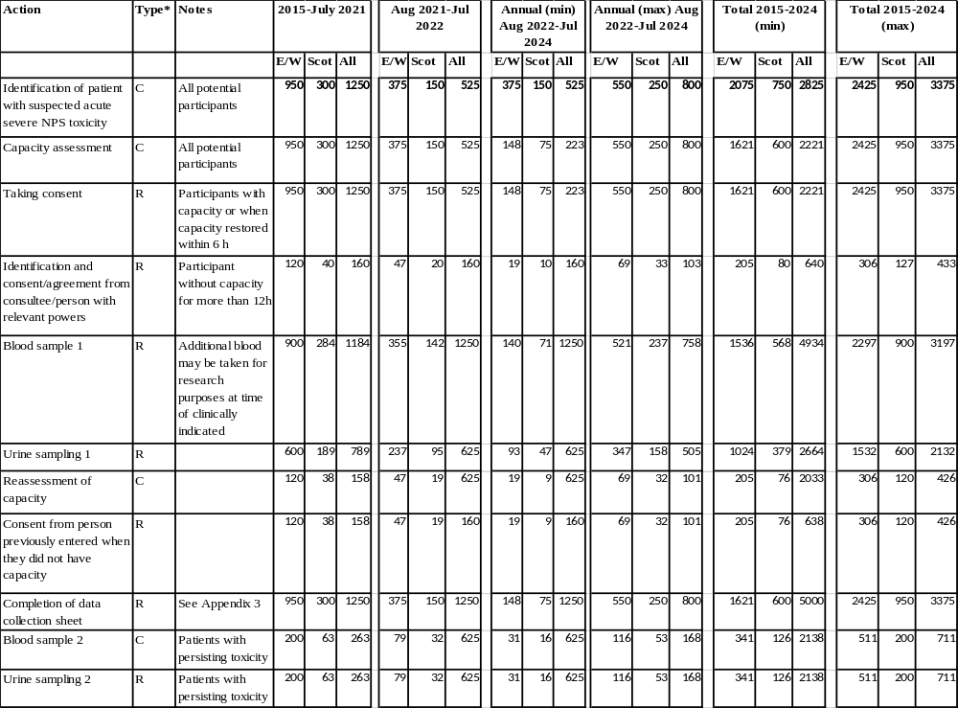

*C = usual clinical practice, R = Research

APPENDIX 3: Data collection sheet
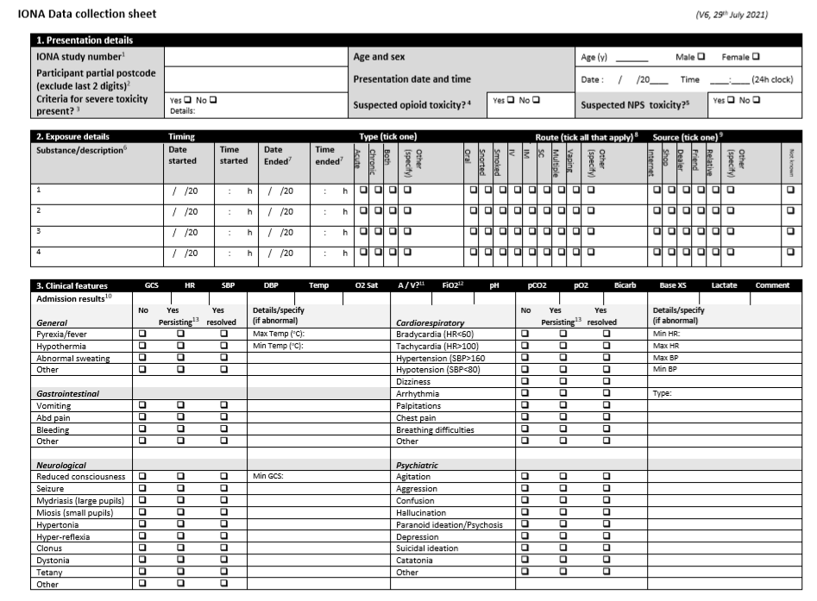
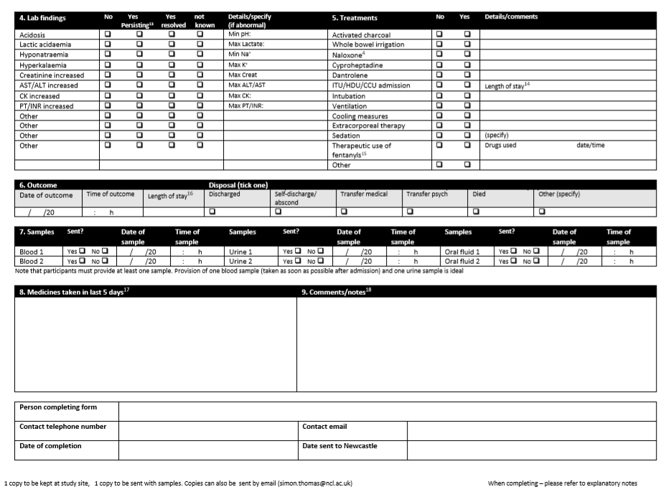
IONA Data collection sheet (V6, 29th July 2021)

Explanatory notes

Please provide as much detail as possible and ensure that all parts of the form are completed. If the data is not available please make a comment to that effect.

- The local lab ID number is unique to the participant and should consist of a standard letter code to identify the study site followed by a number to identify the participant (e.g. RVI-001). This same number should also be used in labelling samples from that participant so that clinical data can be linked to results of sample analysis. The number should also be retained in the local site file so that the local research team is able to link results to that individual.
- The ‘partial’ postcode is used for geographical mapping of exposures and refers to the participant’s home address. It is the full postcode with the final 2 letters omitted. For example the postcode SE1 7RJ would be given as SE1_7 (n.b. not ‘SE17’), while the postcode SE17 4NE would be given as SE17_4.
- Criteria for severe toxicity are given in the protocol and in the table below. Following substantial amendments 6 in England and Wales and 4 in Scotland, these are no longer inclusion criteria but please state if severe criteria (and which) are present.
TABLE: Criteria for severe toxicity (present at any time after exposure)
- Fever > 38.5 ºC  - Clinically important hypothermia  - Glasgow coma scale < 8ª  - ITU/HDU/CCU admission  - Respiratory insufficiency  - Requirement for intubation and ventilation  - Seizures  - Hallucinations/psychosis  - Extreme agitation  - Severe or prolonged (> 24 h) behavioural disturbance  - Arrhythmia  - Chest pain or ECG evidence of cardiac ischaemia or myocardial infarction | - Acidosis (arterial or venous pH < 7.35 or bicarbonate < 20 mmol/L)  - Severe electrolyte or fluid disturbances  - Hypoglycaemia (<1.7 mmol/L)  - Methaemoglobinaemia (>50%)  - Tachycardia > 140 /min  - SBP > 180 mmHg  - SBP < 80 mmHg  - Acute kidney injury^{b}  - Creatine kinase activity raised (> 1000 IU/L)  - ALT/AST activity > 300 IU/L  - PT > 15 s or INR > 1.3  - Death  - Poisons Severity Score⁶¹ of 3 (Severe) ^{c}  - Other severe manifestations of toxicity, as determined and justified by the investigator
ªIn the absence of likely alternative causes (e.g. severe alcohol intoxication, use of sedative drugs etc).
^{b}Defined as a rise in serum creatinine of ≥26 micromol/litre within 48 hours, a 50% or greater rise in serum creatinine known or presumed to have occurred within the past 7 days, or a fall in urine output to less than 0.5 ml/kg/hour for more than 6 h⁶³
^{c}Criteria for PSS 3 relevant to recreational drug use include abnormal chest Xray with symptoms, generalized paralysis, blindness or deafness

- Please indicate by ticking the box if the participant has been included because of suspected severe opioid toxicity. Features that might suggest this include rapidly developing unconsciousness, hypotension, pulmonary oedema, pinpoint pupils and response to the antidote naloxone. Please also note naloxone administration in section 5.
- Please indicate by ticking the box if you suspect involvement of a new psychoactive substance. Clues to this include use a specific named NPS (e.g. mephedrone, ‘products’ (Black Mamba, Clockwork Orange etc), unidentified powders or tablets, ‘spice’ or street drugs.
- Please give as much detail about the substances as you can, i.e. the substances the participant reports he/she has taken, e.g. heroin, Green Rolex, ecstasy, spice, unidentified white powder etc. Please use one row for each substance. Use a further sheet if more than 4 substances. It is recognised that some information may be missing or there may be uncertainty about what has been taken and the timing of that, but please provide what information is available.
- The time and date ended is only required for chronic exposures (e.g. those taken over more than 1 hour). For an acute single exposure these columns can be left blank.
- The route of exposure should be provided for each substance. If multiple routes are used for the same substance please tick all routes that apply and the ‘multiple’ box. If other routes of exposure please tick the ‘other’ box and write in the route next to that. Note oral = ingested, snorted = insufflated.
- If information is available on the source of the substance in question please record that in these columns.
- These should be results taken at (or as soon as possible after) admission, usually from the ED records.
- Specify A for an arterial and V for a venous blood gas sample
- Specify the inspired oxygen for the blood gas sample, e.g. Air, 100% etc.
- Persisting symptoms or laboratory findings are defined as those that are still present at hospital discharge.
- Please specify the numbers of days and hours in critical care.
- Please record if fentanyl or analogues (e.g. remifentanil, sufentanyl, alfentanyl) have been given for therapeutic reasons (e.g. intubation). It is essential to rule out therapeutic use if fentanyl or fentanyl analogues are found in participant samples.
- Please specify the numbers of days and hours in hospital in total
- Please list medicines that may have been taken in the last 5 days, especially psychoactive medicines such as opioids, pregabalin, gabapentin, modafenil etc.
- Comments and further information can be provided in section 9, but be sure not to provide anything that might identify the participant.

Note that there is also an excel data collection tool that collects identical information to this paper version.
If you have any questions, comments or problems relating to the form, please contact the Chief Investigator as follows:
Prof Simon Thomas  Newcastle University  Newcastle NE2 4HH | Tel 0191 282 4642  Fax 0191 282 0288  Email simon.thomas@ncl.ac.uk

APPENDIX 4: Substances detected by current extended drug screen.



https://www.gov.uk/government/uploads/system/uploads/attachment_data/file/98006/temporary-class-drug-factsheet.pdf
http://webarchive.nationalarchives.gov.uk/20130107105354/http://www.dh.gov.uk/prod_consum_dh/groups/dh_digitalassets/@dh/@en/documents/digitalasset/dh_083133.pdf

